EMPLOYEES:

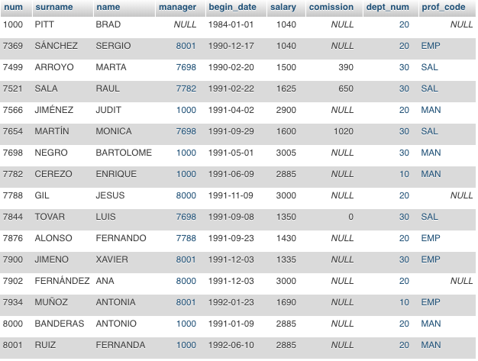

|  |  |
| --- | --- |
| Query 1: | Query 2: |
| SELECT num, salary, dept_num  FROM EMPLOYEES  WHERE  salary > 2000 AND  dept_num = 10 OR  dept_num= 30 | SELECT num, salary, dept_num  FROM EMPLOYEES  WHERE  salary > 2000 AND  (dept_num = 10 OR  dept_num= 30) |

Evaluate the next truth table:

|  |  |  |  |  |  |  |  |  |
| --- | --- | --- | --- | --- | --- | --- | --- | --- |
| num | salary | dept_num | salary > 2000 | dept_num = 10 | dept_num = 30 | dept_num = 10 OR  dept_num= 30 | salary > 2000 AND  dept_num = 10 OR  dept_num= 30 | salary > 2000 AND  (dept_num = 10 OR  dept_num= 30) |
| 1000 | 1040 | 20 | false | false | false | false | false | false |
| 7369 | 1040 | 20 | false | false | false | false | false | false |
| 7499 | 1500 | 30 | false | false | true | true | true | falso |
| 7521 | 1625 | 30 | false | False | True | True | True | False |
| 7566 | 2900 | 20 | True | False | False | False | False | False |
| 7654 | 1600 | 30 | False | False | True | True | True | False |
| 7698 | 3005 | 30 | True | False | True | True | True | True |
| 7782 | 2885 | 10 | True | True | False | True | True | True |
| 7788 | 3000 | 20 | True | False | False | False | False | False |
| 7844 | 1350 | 30 | False | False | True | True | True | False |
| 7876 | 1430 | 20 | False | False | False | False | False | False |
| 7900 | 1335 | 30 | False | False | True | True | True | False |
| 7902 | 3000 | 20 | True | False | False | False | False | False |
| 7934 | 1690 | 10 | False | True | False | True | False | False |
| 8000 | 2885 | 20 | True | False | False | False | False | False |
| 8001 | 2885 | 20 | True | False | False | False | False | False |

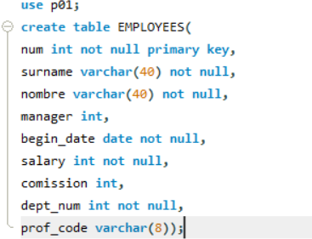

Write here the results of query 1 and query 2:

Query 1:

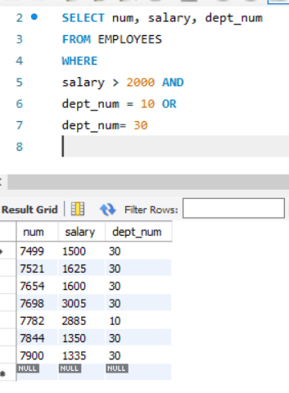

Query 2:

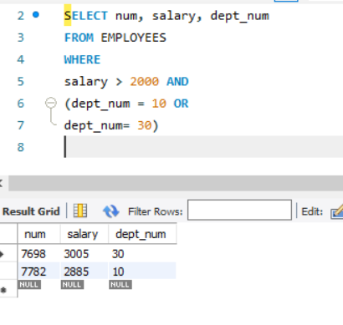

Next, you have to implement this table in mysql,, run the queries again and see if it matches the results that you have obtained manually.